108: Connecting to Orchestration REST API

Friday, November 20, 2015

11:42 AM

Depending on the configuration of your cluster you will have a number of management endpoints exposed. If you chose to create a jumpbox then you can use the web interfaces provided by the Orchestration tools in your cluster. You will also have a number of REST API endpoints to use. In order to connect to any of these endpoints you will need to create an SSH tunnel to the appropriate endpoint.

REST API Endpoints

All REST API endpoints are located on the masters and so first you need to identify the domain name for the Master Load Balancer. If you are using the `acs-base-template` then this will be DNSPREFIXman.REGION.cloudapp.azure.com. To find the DNS name in the portal:

Machine generated alternative text:
acsexample 
Resource group 
Add 
x 
Settings 
Delete 
Subscription ID 
df746c67705 
Location 
Japan East 
All settings 
ADD TILES O 
ADD 
Essentials 
Subscription name 
Microsoft Azure Internal Consumption 
Last deployment 
1 1/19/2015 (Succeeded) 
Summary 
Resources 
agentAvailabilitySet 
masterAvailabilitySet 
agentO 
agentl 
agent10 
agentll 
agent12 
agent13 
agent14 
Monitoring 

Machine generated alternative text:
Resources 
acsexample 
Refresh 
acsexample 
acsexample 
acsexample 
acsexample 
acsexample 
acsexample 
acsexample 
acsexample 
acsexample 
acsexample 
acsexample 
acsexample 
acsexample 
acsexample 
acsexample 
acsexample 
Japan East 
Japan East 
Japan East 
Japan East 
Japan East 
Japan East 
Japan East 
Japan East 
Japan East 
Japan East 
Japan East 
Japan East 
Japan East 
Japan East 
Japan East 
Japan East 
Microsoft Azure Internal C... 
Microsoft Azure Internal C... 
Microsoft Azure Internal C... 
Microsoft Azure Internal C... 
Microsoft Azure Internal C... 
Microsoft Azure Internal C... 
Microsoft Azure Internal C... 
Microsoft Azure Internal C... 
Microsoft Azure Internal C... 
Microsoft Azure Internal C... 
Microsoft Azure Internal C... 
Microsoft Azure Internal C... 
Microsoft Azure Internal C... 
Microsoft Azure Internal C... 
Microsoft Azure Internal C... 
Microsoft Azure Internal C... 
Add 
3 
3 
Columns 
jumpbox-nic 
masterO-nic 
masterl-mc 
master2-nic 
agent-nsg 
jumpbox-nsg 
master-nsg 
acsexample 
acsexamplejb 
acsexampleman 
VNET 
OOhj4y02tyyzvjwmesos1 
60hj4y02tyyzvjwmesos2 
cOhj4y02tyyzvjwmesos3 
hj4y02tyyzvjwmesosO 
iOhj4y02tyyzvjwmesos4 

Machine generated alternative text:
acsexampleman 
Public IP address 
x 
Settings 
Dissociate 
Delete 
acsexampleman.japaneast.cloudapp.azure.. 
IPa ress 
23.102.76.220 
Associated to 
masterlb 
All settings 
Essentials 
Resource group 
acsexample 
Location 
japaneast 
Subscription name 
Microsoft Azure Internal Consumption 
Subscription ID 

Web Interfaces for Management tools

If you want to use the web interfaces for these tools then you will need to have deployed a jumpbox in your cluster. This will be using the DNS name [DNSPREFIX]man.[REGION].cloudapp.azure.com

Setting up an SSH Tunnel

Using SSH

`ssh -L PORT:localhost:PORT -N [USERNAME]@[DNSPREFIX]man.[REGION].cloudapp.azure.com -p SSH\_PORT`

PORT is the port of the endpoint you want to expose.

USERNAME is the username provided when you deployed the cluster

DNSPREFIX is the DNS prefix you provided when you deployed the cluster

REGION is the region in which your resource group is located

SSH\_PORT is either 22 (for the Jumpbox) or 2211, 2212 … 2215 for master0, master1 … master4 REST API's respectively

Now you can access the Marathon API on [DNSPREFIX]man.[REGION].cloudapp.azure.com using `localhost:8080`

For example, to set up a tunnel to the Marathon API in our example cluster:

`ssh -L 8080:localhost:8080 -n azureuser@acsexampleman.japaneast.cloudapp.azure.com -p 2211`

[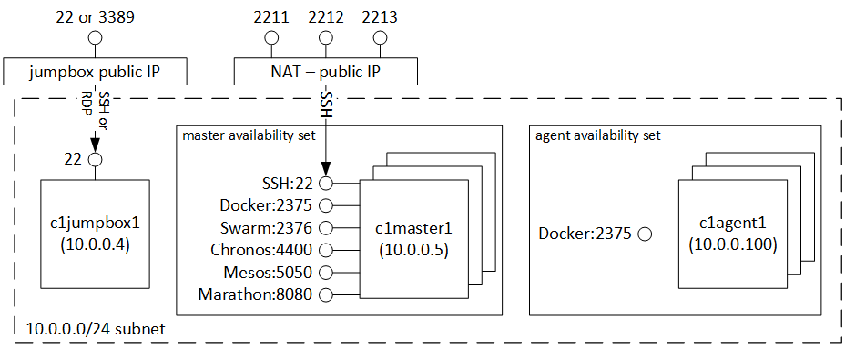](https://raw.githubusercontent.com/anhowe/mesos-scalable-cluster/master/images/mesos.png)

Using Putty

[Download](http://www.putty.org/) and install Putty.

The snapshots below walk you through the steps needed to set up a SSH tunnel

.

Machine generated alternative text:
PuTTY Configuration 
(S" Terminal 
É)• Window 
Behaviour 
Translation 
É• Connection 
SSH 
Basic options for your PuTTY session 
Specify the destination you want to connect to 
Name (or IP address 
azureuser@acsexampleman japaneast 221 Il 
C) Rau C) lelnet C) Rogln @SSH C) Sedal 
Load , save or delete a stored session 
x 
Load 
Saved Sessions 
ACS Example 
Defauh Settings 
ACS Demo 
ACS Demo Ned 
ACS Swarm 
connectacs 
rgdockerdev 
Close window on exit: 
C) Aways O t'Lver @Orb' on clean exit 
Cancel 

Machine generated alternative text:
PI-ITTY Configuration 
Category: 
É)• Window 
Behaviour 
Translation 
ÉJ• Connection 
($• A_fth 
Tunnels 
More bugs 
Options controlling SSH port forwarding 
Port forwarding 
Local ports accept connections from other hosts 
Remote aorts do the same (SSH-2 only) 
Forwarded ports: 
Add new 
Source port 
Destination 
@Local 
st eoecl 
Bemove 
C) D•man-uc 
C) IPvE 